HELP US

HELP YOU

STAY WELL THIS WINTER

Emergency Appointments at Elm Hayes.

Please be aware that even though you are given an appointment time - this is only a guide and there may be a long wait for your emergency appointment, especially during the winter months. Thank you.

In BaNES there are numerous ways to access health care advice and treatment, such as:-

Minor Injury Unit MIU – Next Door at Paulton Hospital is our MIU, they treat non life-threatening injuries such as bites, sprains, infections and broken bones. The service is run by experienced nurses on a first come – first served basis, you don’t need to book an appointment.

Self Care – The first point of call for any minor illness or injury. Start tackling your symptoms straight away and help us free up GP appointments for those who really need them.

Pharmacy – Experts in medicines can provide advice on a number of common ailments. A visit to your local pharmacy could stop a minor illness getting worse and prevent you needing to go to your Doctor.

A & E Department - Only use the A&E Department in very serious circumstances such as stroke, severe bleeding, heart attack, severe head injury or fits that do not stop.

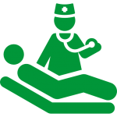 GP and GP Out of Hours Services – treats conditions that cannot be treated with self-care, over the counter medications, or advice from a pharmacy. Deals with a range of health problems. The GP out of hours service is available when your surgery is closed.

NHS Choices – The UK’s biggest website. Lots of information and advice to support your self care. Available 24 hours a day 365 days a year.

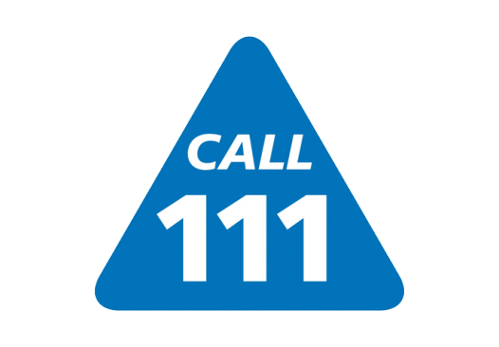NHS 111 – A free non emergency phone service available 24 hours a day, 365 days a year. Trained call handlers will listen to your symptoms and direct you to the best medical care for you.

Vomiting and Diarrhoea
Information - Vomiting in adults is usually not a sign of anything serious and tends to only last one or two days. Vomiting is the body's way of ridding itself of harmful substances from the stomach, or it may be a reaction to something that has irritated the gut. One of the most common causes of vomiting in adults is gastroenteritis. This is an infection of the gut usually caused by bacteria or a virus, such as a norovirus (see video, left). Gastroenteritis also causes diarrhoea. Your immune system will usually fight off the infection after a few days.
Looking after yourself - The most important thing you can do when vomiting is to keep taking small sips of fluid so you don't become dehydrated. Drink water, squash, diluted fruit juice or semi-skimmed milk. A sweet drink can be useful for replacing lost sugar and a salty snack, such as a packet of crisps, can help replace lost salt. You may find that ginger helps to relieve your nausea and vomiting. Try drinking fresh ginger stewed in a mug of hot water.

 Viral Ilnesses, The Common Cold and Flu

Information - You can often treat a viral illness such as the common cold or flu without seeing a GP. You should begin to feel better in about a week or 2.

Antibiotics - Your GP or Nurse will not be able to prescribe antibiotics for colds or flu as they do not relieve your symptoms or speed up recovery. Antibiotics are only effective against bacterial infections.

Looking After Yourself - You can buy cough and cold medicines from the Pharmacy or Supermarkets, pain killers can lower temperatures and relieve aches and pains. Flu vaccines can reduce the risk of catching flu – please make sure you get your flu injection if you are over 65 years of age or in one of the “at risk” groups.

Cold Weather


Cold weather can be very harmful, especially in people aged 65 or older.

It can weaken the immune system, increase blood pressure, thicken the blood and lower body temperature, increasing the risks of heart attack, stroke or chest infection.

It is important to keep well in winter, both inside and outdoors as it can help prevent colds, flu and more serious health problems.

Heat your home to at least 18 degrees celcius/ 65 degrees farenheit – you might prefer your living room slightly warmer.
Surgery & Dispensary
Opening Hours
Mon – Fri 8am – 6pm

Extended Opening Hours
We offer a range of Extended Hours Appointments in the mornings, evenings and some Saturday mornings.

Improving Access Service
We also host the BANES Improving Access Service for GP and Nurse appointments every evening from 6pm – 9pm and Saturday and Sunday mornings.

If you find it difficult to attend during normal surgery hours please ask for one of these appointments.

Out of Hours Emergency Telephone Number
111

