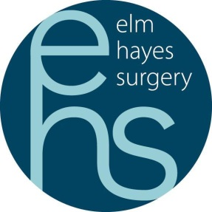
Elm Hayes Surgery
We are a friendly, part dispensing practice located south of the beautiful city of Bath. 9,000 patient practice in modern purpose built premises (2009). We are an active member of the Three Valleys Primary Care Network.
Salaried GP to commence as soon as possible for up to
up to 8 sessions per week

Position will close when we have a successful applicant

- Systm1 Practice
- CQC rated – Good
- High achieving QOF practice
- Experienced supportive GP Partnership Team who meet daily for peer review and discussion meetings supported by
- Salaried GPs
- Advanced Nurse Practitioners
- Experienced Chronic Disease Management Nurses and HCA Team
- Clinical Pharmacist, Social Prescriber and First Contact Physiotherapists
- Excellent administrative support with dedicated PA
- Home Visiting Service run by GPs and Paramedic Practitioners
- Multi-disciplinary community team
- Complementary therapy suite
- In house Dermatology, Audiology & Community Paediatricians

For an informal visit or to discuss these vacancies further please contact:
Sharon Taylor, Practice Manager at Elm Hayes Surgery, Clandown Road, Paulton, Bristol, BS39 7SF or telephone on 01761 413155

