Dear Patient

We are here to help

As we are still in the Covid pandemic, the NHS recommends that we triage or phone back every patient who wants advice from a nurse, doctor or other healthcare professional.
If you need medical advice or treatment, please ring us on 01761 413155
or visit our website elmhayessurgery.co.uk and send us your query
Our opening hours are Monday – Friday 8am – 6pm
We ask many of the patients we have telephoned, to then come to the surgery for a face-to-face appointment, but due to infection control measures and social distancing, we can only let patients into the surgery if they have a planned appointment.

We are keen, as we are sure you are too, to avoid transmission of infection and so to ensure social distancing we are closely monitoring how many patients are in our building including sitting in the waiting room. We need to take more precautions than shops etc due to the vulnerability of some of our patients.

We know that some of these measures are frustrating for you as they are for us. We are facing unprecedented demands with a huge increase in the number of calls we are receiving and the need for us all to catch up with the monitoring of patients which was not possible in the height of the pandemic.

We all look forward to lockdown measures continuing to ease but in the meantime, many thanks for your patience and understanding

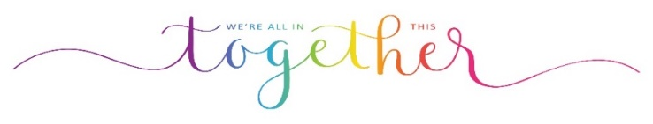
Dr Stephens and Partners/Practice Manager
12.05.21

