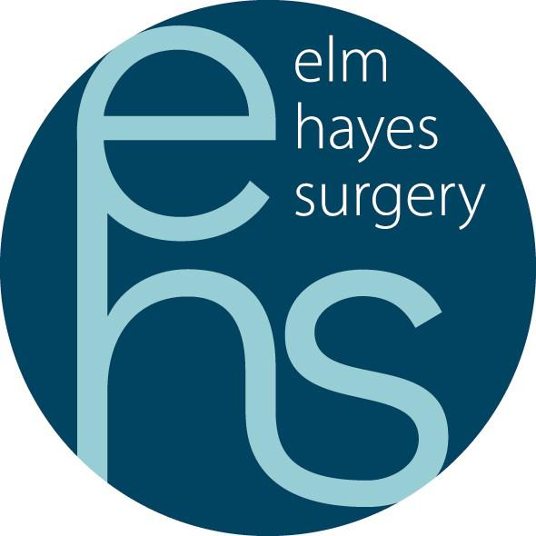

Current Vacancy

**Medical Receptionist/Care Navigator Required**

We currently require a Medical Receptionist / Care Navigation Staff to join our friendly and supportive reception team.

Up to 25 Hours per week to cover shifts from 8am – 6pm Monday to Friday plus flexibility required for overtime for sickness and holiday cover.

Informal enquiries/visits welcome.

Our Care Navigators are the first point of contact at the practice. Main duties will include booking/cancelling of appointments, taking telephone enquiries and ensuring the smooth running of the surgery day to day whilst working on the front desk and telephones. To provide general assistance to the practice team and project a positive and friendly image to patients and other visitors, both in person and via the telephone.

**Job Responsibilities:**

Act as first point of call for all patient enquiries and ensure an effective and efficient reception service is provided to patients and any other visitors to the practice.

Deal with all general enquiries and make new and follow up appointments, signpost to appropriate services and record requests for home visits.

There will also be a variety of administrative tasks to include managing incoming and outgoing mail and communications, processing repeat prescriptions and recording of information in line with the practice policy.

Undertake any additional administrative duties appropriate to the post as requested by the Partners or the Practice Manager and Management Team.

Please apply in writing with a CV to and covering letter to: -

Amy Dando, Elm Hayes Surgery, Clandown Road, Paulton, Bristol, BS39 7SF Tel 01761 404221 or email bswicb.elmhayes@nhs.net

Closing date Tuesday 6th May 2025 – we reserve the right to close this vacancy early should a suitable candidate be appointed.